

**INDUSTRIAL INTERNSHIP REPORT**

TITLE OF THE PROJECT

**ONLINE FOOD ORDER USING ANDROID**

**Submitted By**

**Name** :- Ankit Senjaliya

**Enrollment No.** :- 19BT04046

**Course** :- B.Tech Computer Science And Engineering

**Submitted To**

**Name** :- Ms. Avneet Saluja

GSFC University, Vadodara

**Internship Information**

Internship Institution :- MDIDM INFOWAY

Rajkot

Internship Period :- 1 Month

Date Of Report Submission :- 29th July, 2022

**CERTIFICATE**

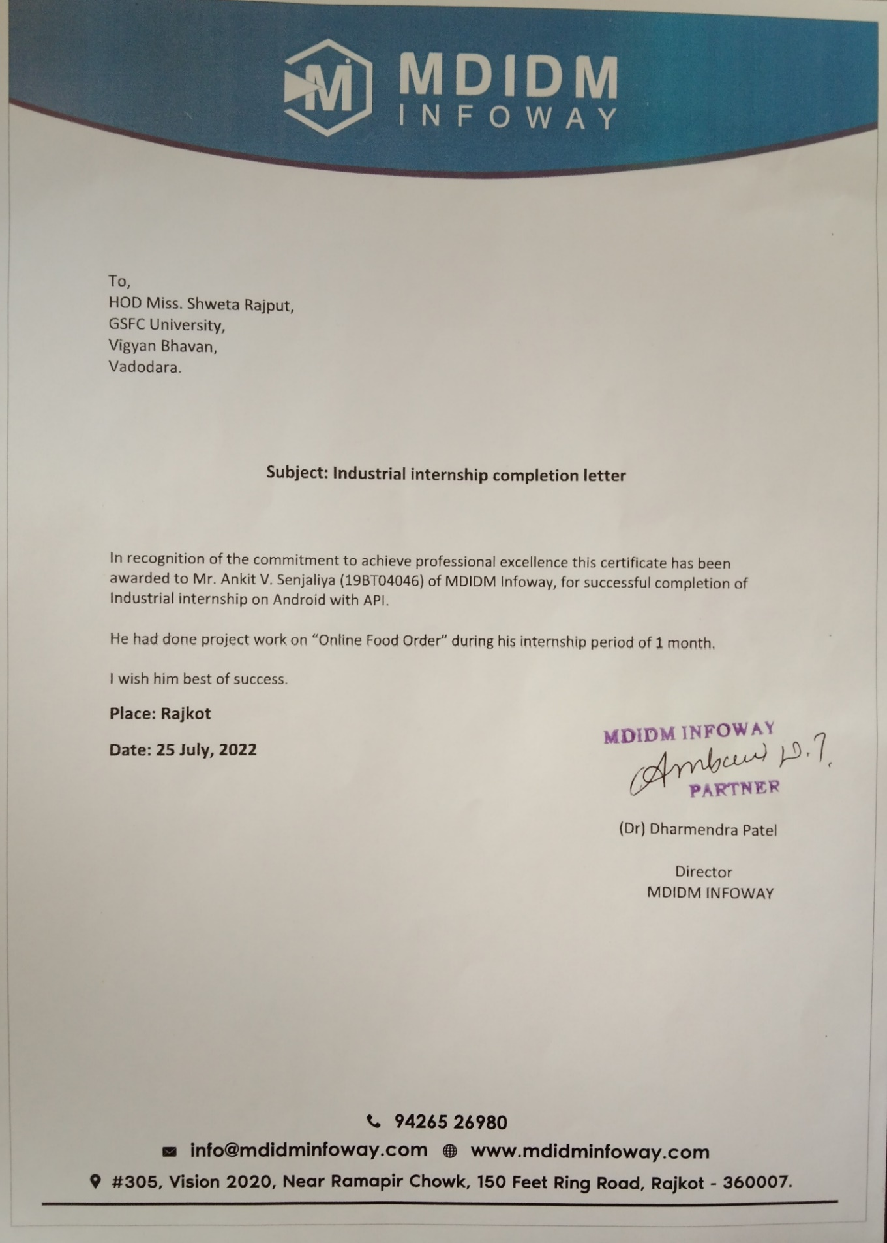

**TABLE OF CONTANT**

|  |  |  |
| --- | --- | --- |
| **Sr. No.** | **Title** | **Page No.** |
| 1 | Acknowledgment | 2 |
| 2 | Abstract | 3 |
| 3 | Introduction | 4 |
| 4 | Requirements | 5 |
| 5 | Application Framework | 6 |
| 6 | Database Framework | 8 |
| 7 | Testing | 9 |
| 8 | System Analysis | 11 |
| 9 | Diagram | 12 |
| 10 | Code (Google Drive) And Screenshot |  |
| 11 | Future work, Conclusion, References |  |

**ACKNOWLEDGEMENT**

* I have taken efforts in this project. However, it would not have been possible without the kind support and help of many individuals and organisations. I would like to extend my sincere thanks to all of them.
* I am highly indebted to **Mr. Dixit Dobariya (Android Developer)** for their guidance and constant supervision as well as for providing necessary information regarding the project & also for their support in completing the project.
* I would like to express my gratitude towards my parents & member of **GSFC University, Vadodara** for their kind co-operation and encouragement which help me in completion of this project.
* I would like to express my special gratitude and thanks to industry persons for giving me such attention and time. my thanks and appreciations also go to my colleague in developing the project and people who have willingly helped me out with their abilities."
* The above Example of acknowledgement for project. Report may give you some insight of thing that should be mentioned on every acknowledgement for project Report, However we shortlisted a Best acknowledgement letter format for project, I believe you will like it. This Sample of Acknowledgement for Project Reports can also be used in project Reports other than B. Tech Projects Reports with some Modification.

With Sincere Regards,

Name :- Ankit Senjaliya Enrollment No. :- 19BT04046

**ABSTRACT**

* The purpose of this research is making an ordering food application based on Android with New Order, Order History, Restaurant Profile, Order Status, Tracking Order, and Setting Profile features.
* The research method used in this research is water model of System Development Life Cycle (SDLC) method with following phases: requirement definition, analyzing and determining the features needed in developing application and making the detail definition of each features, system and software design, designing the flow of developing application by using storyboard design, user experience design, Unified Modeling Language (UML) design, and database structure design, implementation an unit testing, making database and translating the result of designs to programming language code then doing unit testing, integration and System testing, integrating unit program to one unit system then doing system testing, operation and maintenance, operating the result of system testing and if any changes and reparations needed then the previous phases could be back.
* The result of this research is an ordering food application based on Android for customer and courier user, and a website for restaurant and admin user. The conclusion of this research is to help customer in making order easily, to give detail information needed by customer, to help restaurant in receiving order, and to help courier while doing delivery

**INTRODUCTION**

* The population in Indonesia especially in Jakarta is growing from year to year. It gives opportunities to the restaurant industries to develop their business. According to the population census in 2010, Jakarta population had recorded by more than 9,6 million people with 1 to 2 percent(s) growing each year.
* Android is a software stack for mobile devices that includes an operating system, middleware and key applications. Android is a software platform and operating system for mobile devices based on the Linux operating system and developed by Google and the Open Handset Alliance. It allows developers to write managed code in a Java-like language that utilizes Google-developed Java libraries but does not support programs developed in native code.
* The unveiling of the Android platform on 5 November 2007 was announced with the founding of the Open Handset Alliance, a consortium of 34 hardware, software and telecom companies devoted to advancing open standards for mobile devices. When released in 2008, most of the Android platform will be made available under the Apache free-software and open-source license.
* The growing number of restaurants makes restaurant development more competitive. Therefore, all restaurants keep improving their quality of service; one of the services is delivery order. Delivery order service offered by a number of restaurants is by making order through mobile phone. By following the technology development, some popular restaurants offered website as a choice for making orders in online mode.
* Making orders through phone calling, short messages, or even website does not give order status information in real time to its customer. Moreover, customers can not see their order history which has been done before. Nowadays, mobile phone is not used for calling or SMS only, many mobile phones also provide application that support people daily activities.
* According to Ericsson Lab research from early 2011 until the end of 2011, smart phone users especially in Indonesia are increasing significantly. Based on the data in the end of 2011, the smart phone operating system that is widely used is dominated by some leading platforms such as Android, iOS, and Blackberry. Android is one of the most rapidly increased platforms. In Indonesia, the International Data Corporation (IDC) recorded that the smart phone market share with Android platform raised from the third quarter of 2011 until the end of the fourth quarter of 2011 by 28 percent.

**REQUIREMENTS**

* HARDWARE REQUIREMENTS

* 2.5GHz dual-core Intel Core i5
* 2 GB memory
* 160 GB hard drive
* Intel HD Graphics 4000
* OS Windows Platform
* SOFTWARE REQUIREMENTS
* Tool: code
* Front-End: Android
* Back-End: PHP With API
* Operating System Name
* Android Studio

**Application Framework**

* Pick The Food application is created by using waterfall model of System Development Life Cycle (SDLC). The SDLC phases are:

1. Requirements definition :-

* Analyzes based on similar application and determines the necessary features in the application, as well as do the details about the features that will be created with function of each features.
* Features that are needed in application for customer are as follows:

1. New Order :-

* New Order is the main feature of the customer side application that will be used to make orders. There are two ways to make an orders, the first one is using Make a new order feature to make an order by choosing restaurant and menus provided freely, and the second one is using My Favorites feature to make an order by choosing one of the top three favorites restaurant.

1. Order History :-

* Order History is the feature that will be used to show customer’s order history. This feature is divided to three parts, which are Last order, Last 3 orders, and Last 7 orders that have been made by customer.

1. Restaurant Profile :-

* Restaurant profile is the features that will be used to show restaurant profile. Customer can make a call directly to the restaurant through this feature.

1. Customer Profile :-

* Profile is the feature that will be used to show restaurant profile. Restaurant can also modify its data including change password, edit profile, and change restaurant logo.

1. Order :-

* Order is the feature that will be used to show incoming order. Restaurant can also update order status, assign courier, and show order history through this feature.

1. Menu:-

* Menu is the feature that will be used to show the list of menus. There are two types of menu which are “food” and “beverage”. Restaurant can also modify its menu including change the availability status of each menu through this feature.

1. System and software design :-

* Make the application design workflow for customer side, restaurant side, courier side, and admin side using the storyboard design; the user experience design; the Unified Modeling Language (UML) design consist of use case, class diagram, sequence diagram, and activity diagram; and database structure design.

1. Storyboard design :-

* The storyboard design is designing the user interface including each interface description.

1. User experience design :-

* The user experience design is designing the totality of end user perception when interacting with the application.

1. UML design :-

* The UML design consists of use case to define the system function from each actor perspective then completed by explanation in use case narrative, activity diagram to draw the process of each actor in diagram, class diagram to draw object or class of system with its relationship, and sequence diagram to draw the message interaction with its objects base on its order of time.

1. Database structure design :-

* Database structure design is made by the result of class diagram. It draws the classes that need to be saved in database and its relationship.

**DATABASE FRAMEWORK**

* Online Food ordering system is a process in which one can order various foods and beverages from some local restaurant and hotels through the use of internet, just by sitting at home or any place. And the order is delivered to the told location.
* The Online Food Order System In PHP is a simple project developed using PHP, HTML and CSS. The project connects different restaurants with customers. The project contains an admin(manager) and the user side. All the management like editing site contents, updating food items, adding restaurants, and checking order status can be managed from the admin side. There can be many managers on the site.
* For the user section, the users can go through the homepage, about, and contact pages. In order to order the food items, the user has to create an account and sign in or log in. The food comes with the cost as well. This project makes a convenient way for customers to buy/purchase food online, without having to go to the restaurant.
* This Online Food Order System is in PHP, JavaScript, and CSS. Talking about the features of this system, it contains the admin(manager) section and the user (customer) section. All the editing’s, updating, managing order details, food items, and restaurants are from the admin section while customers can only go through the site and give orders if want. The design of this system is simple so that the user won’t get any difficulties while working on it.
* This is an Online ordering system written using PHP/phpmyadmin.

### **The features of this system are the following:**

* Order product online
* Upload product design online
* Add, Edit, Delete product
* Send order Confirmation via Email
* Manage Online Order
* Ajax Hierarchical Combobox for Payment Method.
* Add Delivery Charge Outside the Coverage Area

**TESTING**

* Testing is one of the important steps in system development. Software Testing also provides an objective, independent view of the software to allow the business to appreciate and understand the risks at implementation of the software. Test techniques include, but are not limited to, the process of executing a program or application with the intent of finding software bugs.
* Software Testing can also be stated as the process of validating and verifying that a software program/application/product:

1. Meets the business and technical requirements that guided its design and development.
2. Works as expected
3. Can be implemented with the same characteristics. Software Testing, depending on the testing method employed can be implemented at any time in the development process. However, most of the test effort occurs after the requirements have been defined and the coding process has been completed. As such, the methodology of the test is governed by the Software Development methodology adopted.

* Testing Levels

* Tests are frequently grouped by where they are added in the software development process, or by the level of specificity of the test.

1. Unit Testing

* Unit Testing refers to tests that verify the functionality of a specific section of code, usually at the function level. In an object-oriented environment, this is usually at the class level, and the minimal unit tests include the constructors and destructors.
* These types of tests are usually written by developers as they work on code (white- box style), to ensure that the specific function is working as expected. One function might have multiple tests, to catch corner cases or other branches in the code. Unit testing alone cannot verify the functionality of a piece of software, but rather is used to assure that the building blocks the software uses work independently of each other. Unit testing is also called Component Testing.

1. System Testing

* System Testing tests a completely integrated system to verify that it meets its requirements.
* Types Of Testing

1. Functional Testing

* It is an approach to testing where the tests are derived from the program or component specification. The system is a black box whose behavior can only be determined by studying its inputs and the related outputs.

1. Structural Testing

* Structural testing is an approach to testing where the tests are derived from knowledge of the software ‘s structure and implementation. This approach is sometimes called white-box testing’ to distinguish from black –box testing.

## SYSTEM ANALYSIS

## Feasibility Study

* Feasibility study is the most important of analyses through which analyst can come to know whether their system is practically possible or not for that analyst have to make study over system in different -different aspects. Following are three ways through which we can check feasibility of system.

1. Technical Study

* After doing feasibility study for the system, we come one conclusion that ANDROID as a front- end tool and JSON Parsing back-end tool. And system requirement can be easily fulfilled using this tool. So, we can say that this system is technically feasible.

## Economic Study

* For doing economical study we have to compare all the incomes and expenses related to this application. From incomes and costs comparisons we can say that this system is economically feasible for all Users.

## Operational Study

* After operational feasibility we can say that this system will be operational feasible because that system will be JSON based and user working without internet, they have basic knowledge of internet and computer so it is easy to explain them and this system is operation feasible.

**DIAGRAM**

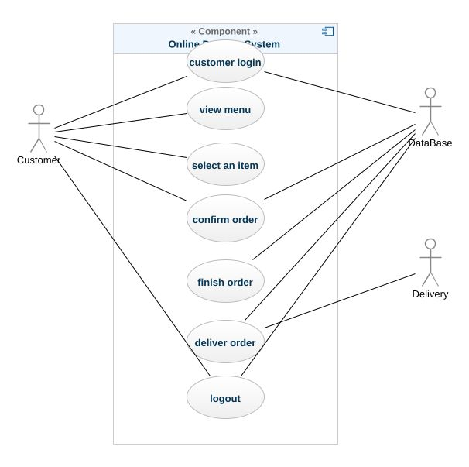

**Code (Google Drive) And Screenshot**

Code Google Drive Link :- <https://drive.google.com/drive/folders/1mxz_UAvw2UUuDh2gXWNqoUCI_9v-gjE4?usp=sharing>

Admin Panel Website Link :-

<https://foodorderfreedelivery.000webhostapp.com/>

**FUTURE WORK**

* Order status is the feature that will used to show order status consist of “order received” means that order has been received by restaurant, “order confirmed” means that order has been confirmed by restaurant, “cooking” means that order has being prepare by restaurant, “delivering order” means that order has being delivery, and “done” means that order has been done. Customer can also show the delivery map while the status is on “delivering order”.
* Tracking order is the feature that will be used to show delivery map, consist of courier position and customer address.

**CONCLUSION**

* Pick The Food application can help customer in making order easily,
* Pick The Food application gives information needed in making order to customer.
* Pick The Food website application made for restaurant can help restaurant in receiving orders and modifying its data.
* Pick The Food website application made for admin can help admin in controlling all Pick The Food system.
* Pick The Food application made for courier can help courier while doing delivery.

**REFERENCE**

1. <http://stackoverflow.com>

2. <http://quora.com>

3. <http://android.net>

4. <http://androidpoint.com>

5. <http://php.net>

6. <http://tutorialpoints.com>